Initial Setup Steps
Step 0: Download and Install Git Bash
Note: I already had the git installed in my machine so did not need to install it again.
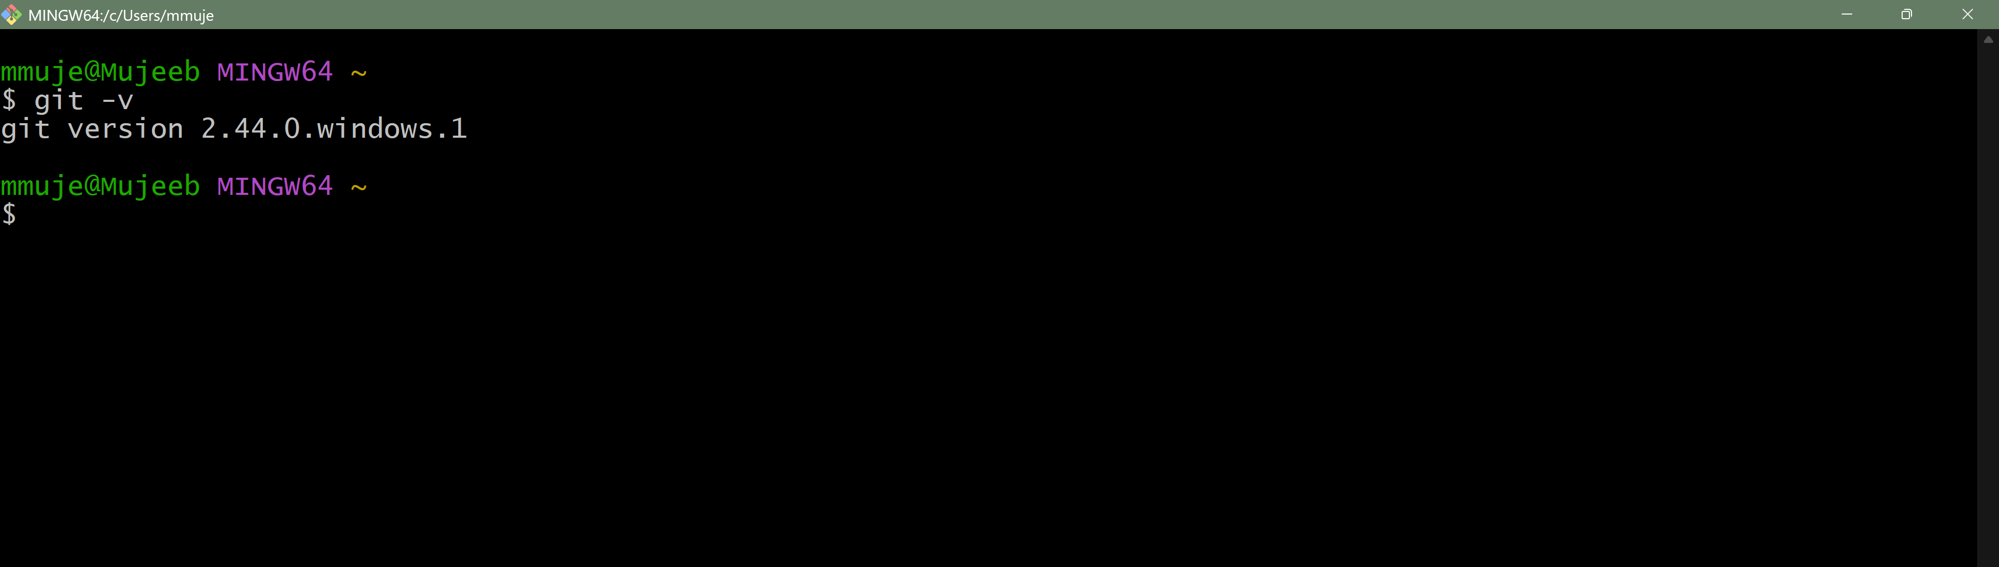

Step 1: Initialize Git with Your Identity


Step 2: Generate and Add an SSH Key for GitHub Authentication
- Generating an ssh key
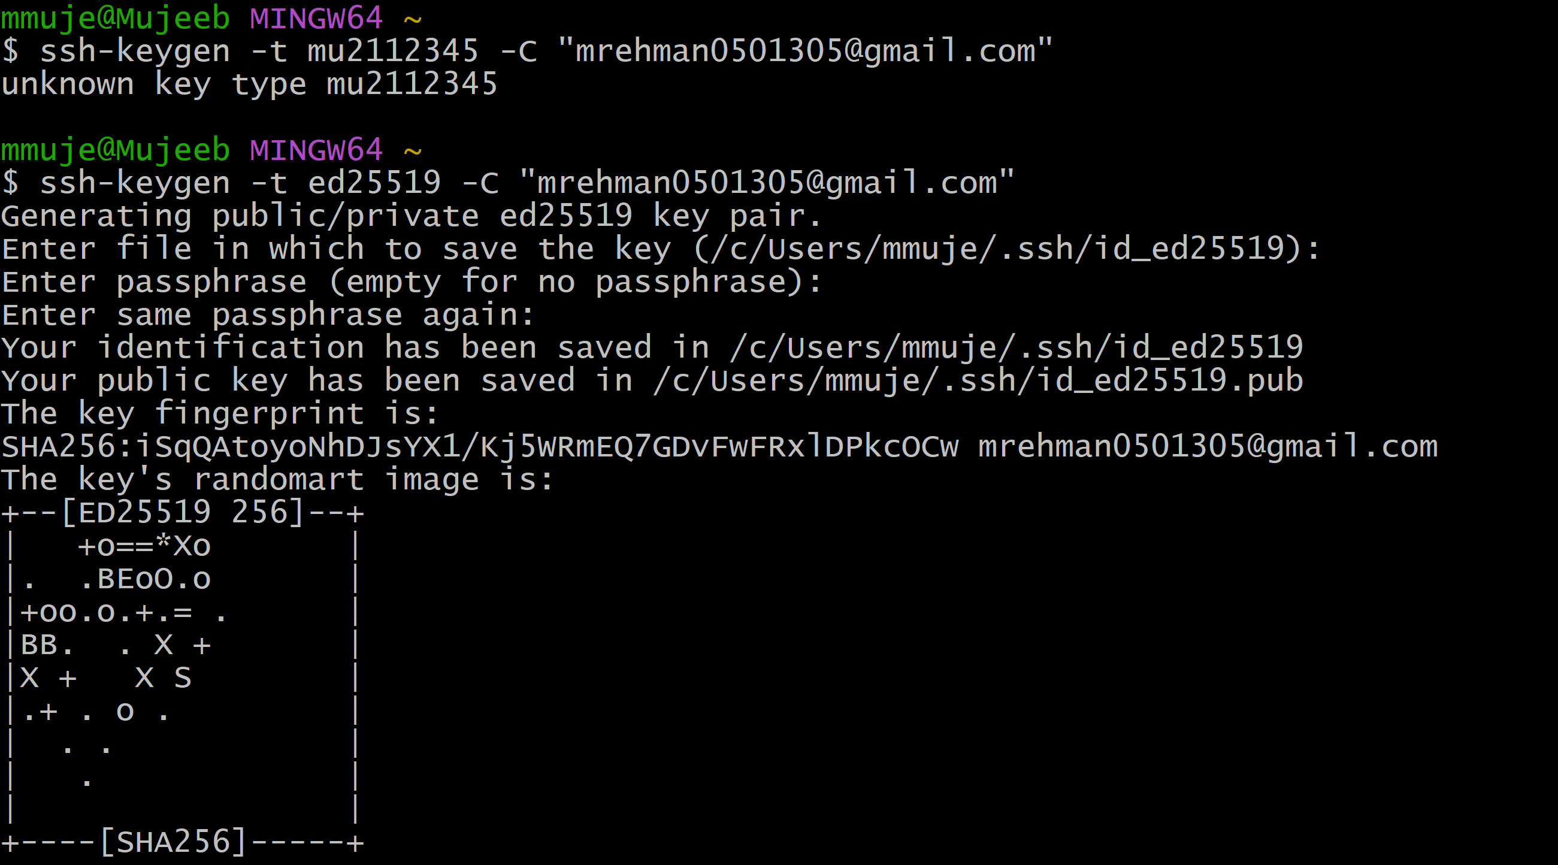

- Start the SSH agent:


- Add your SSH private key to the agent:
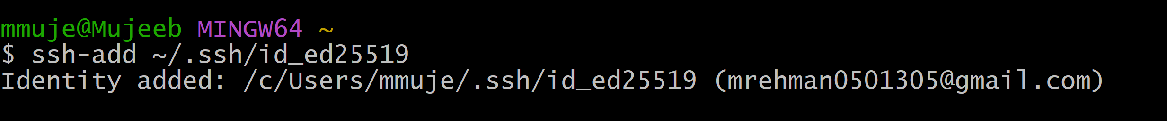

- Copy the public key to your clipboard:

- Adding ssh key to GitHub account
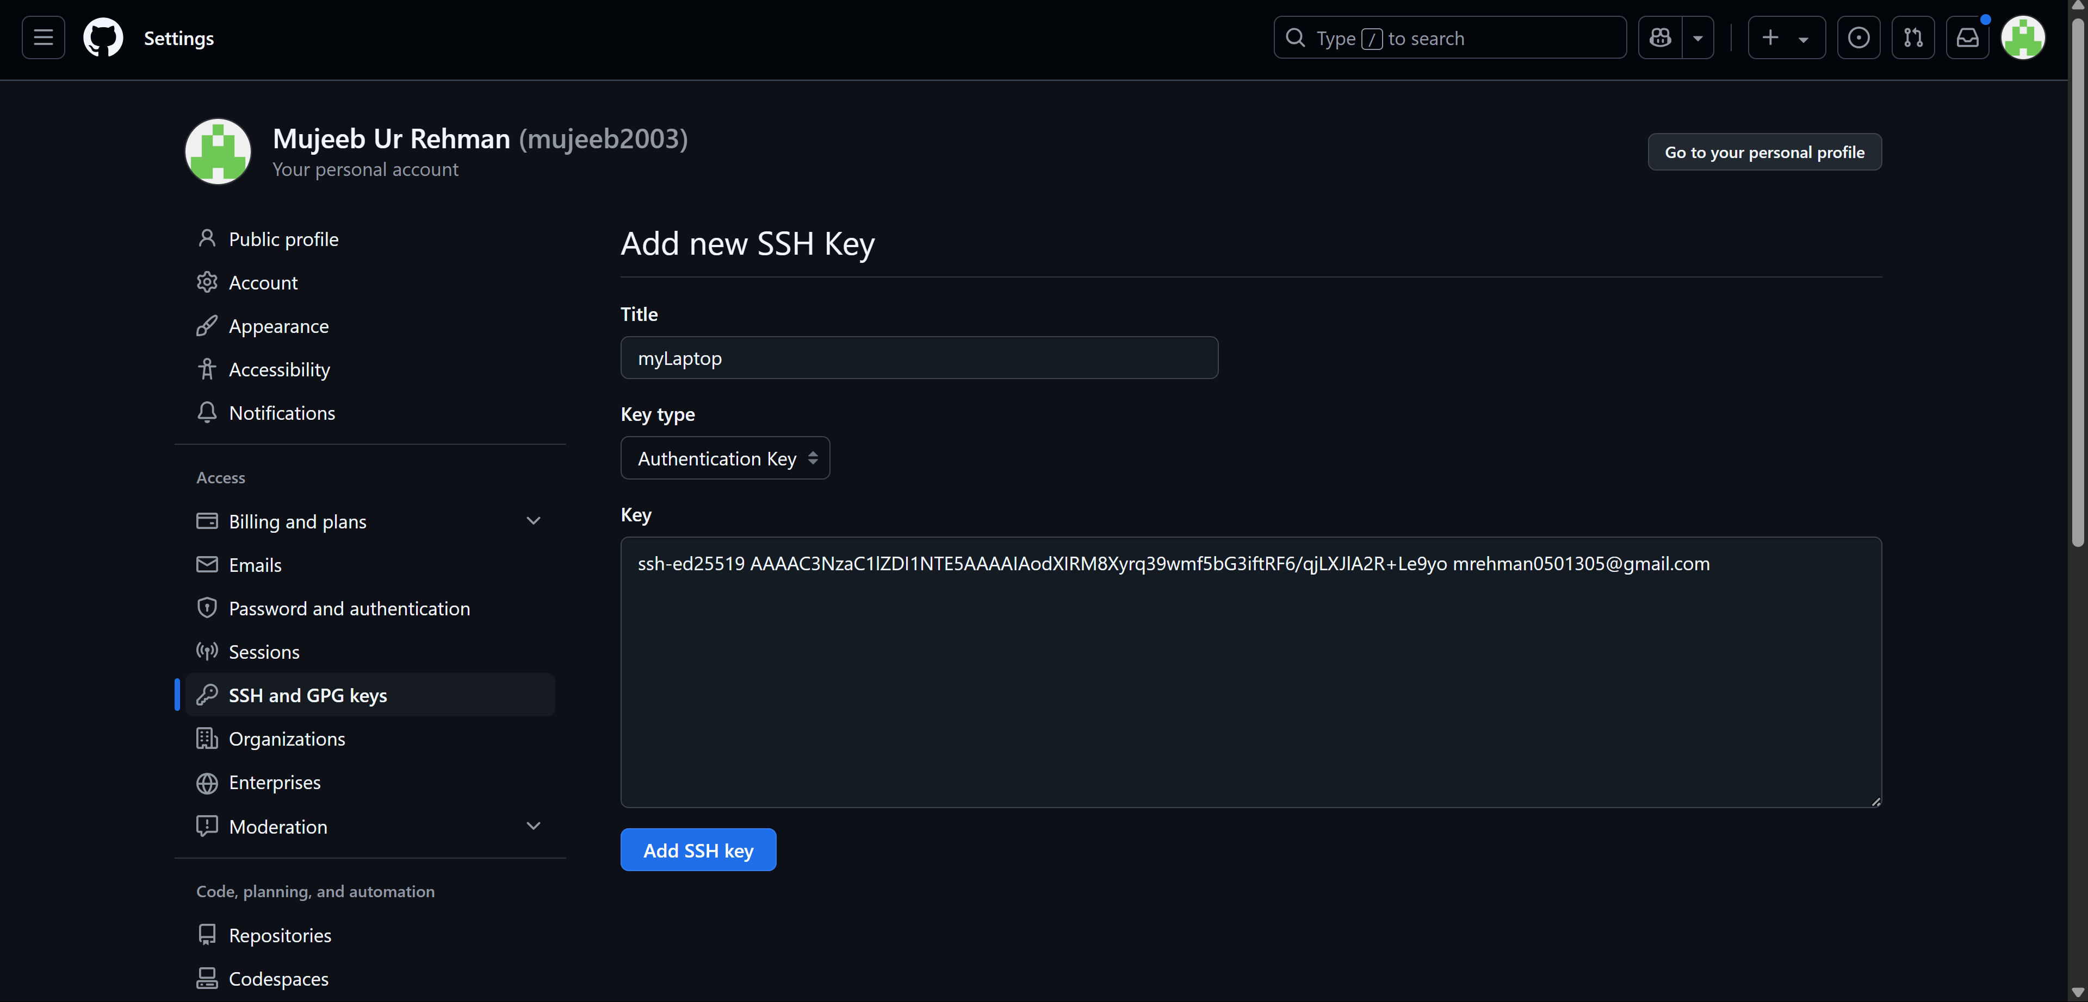

- Testing ssh key connection

Assignment Steps
Step 3: Create a GitHub Repository
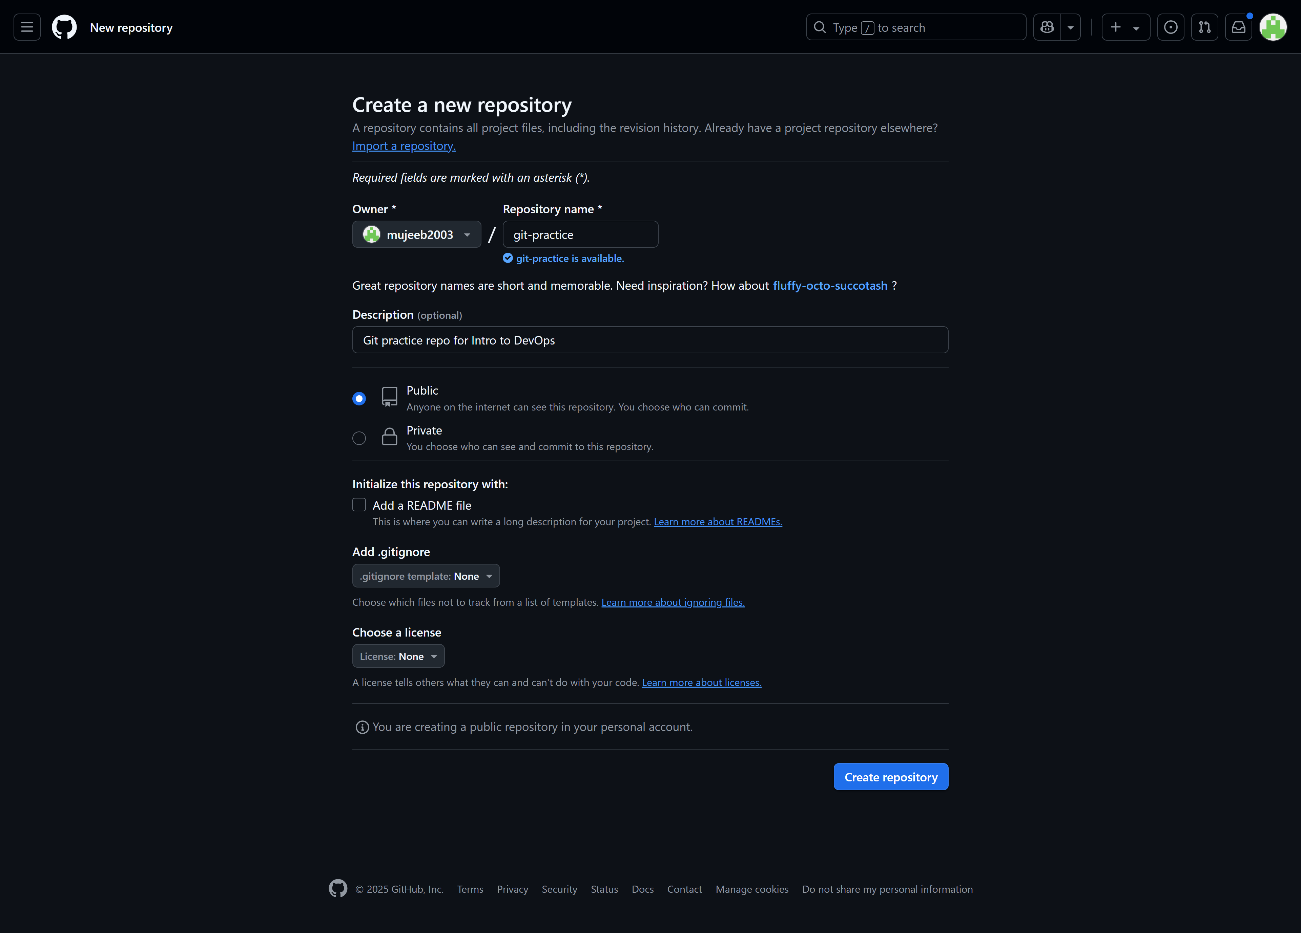

Step 4: Clone the Repository
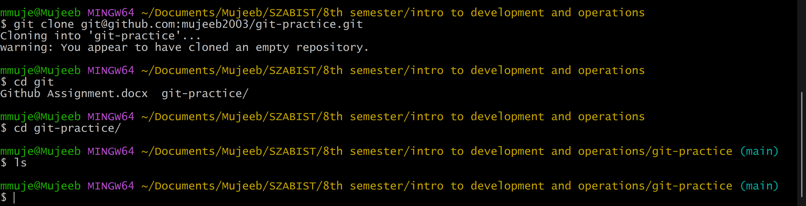

Step 5: Make Changes Locally
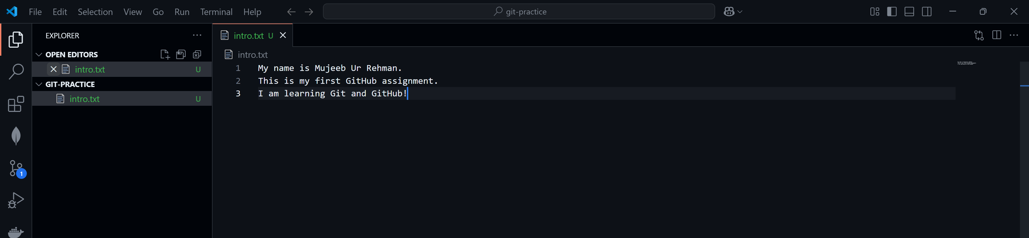

Step 6: Stage and Commit Changes
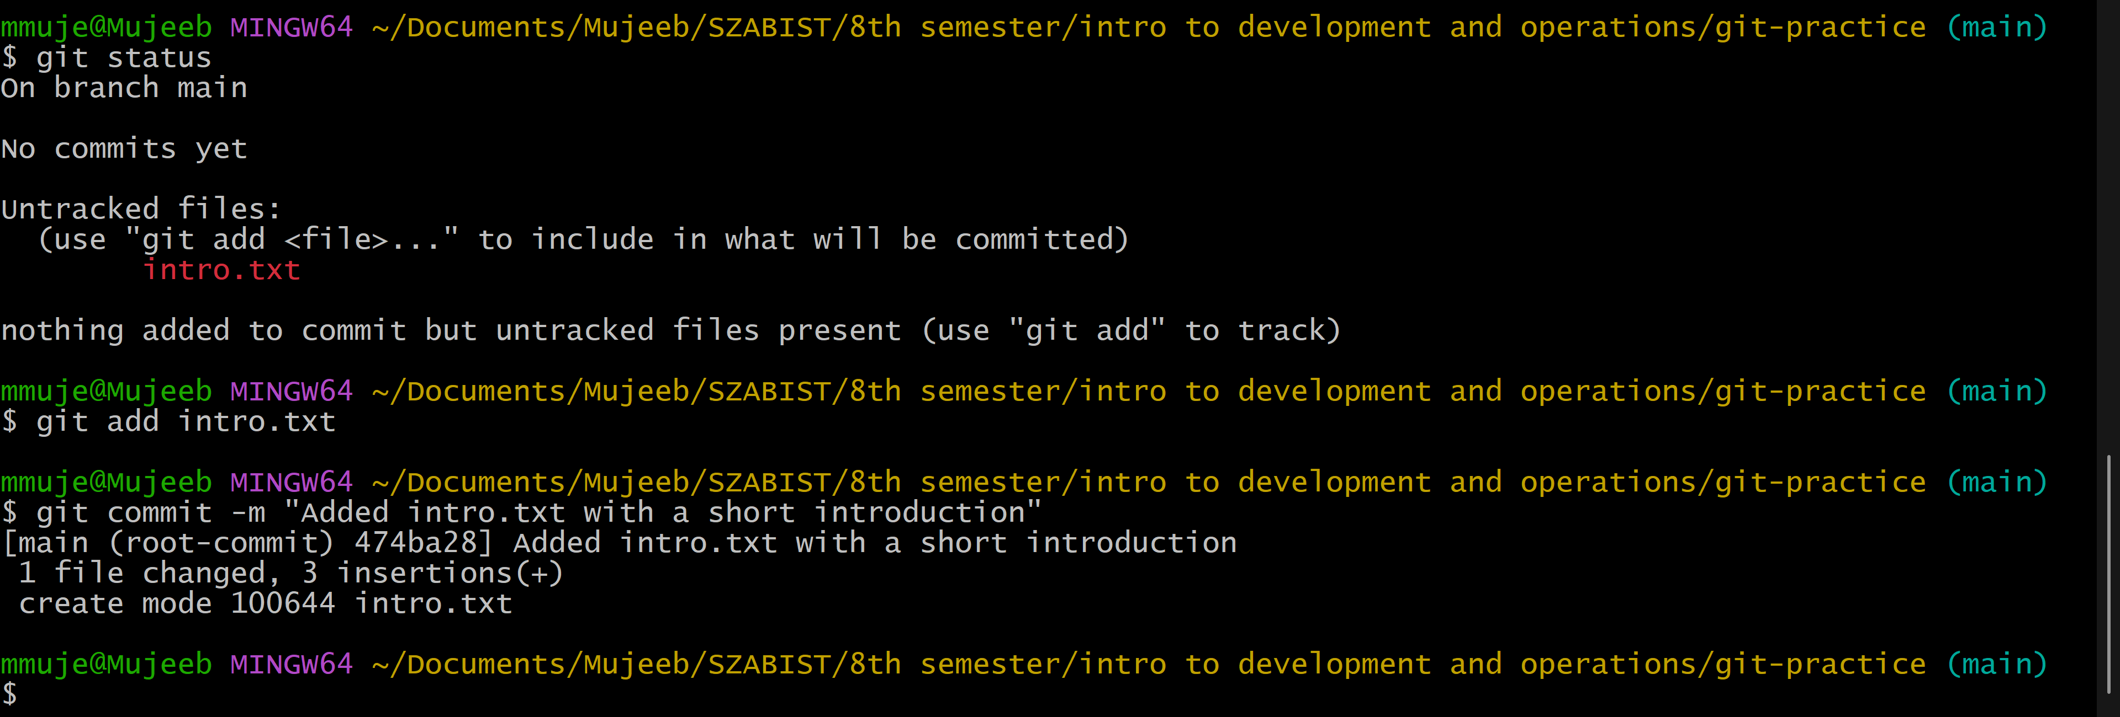

Step 7: Push to GitHub
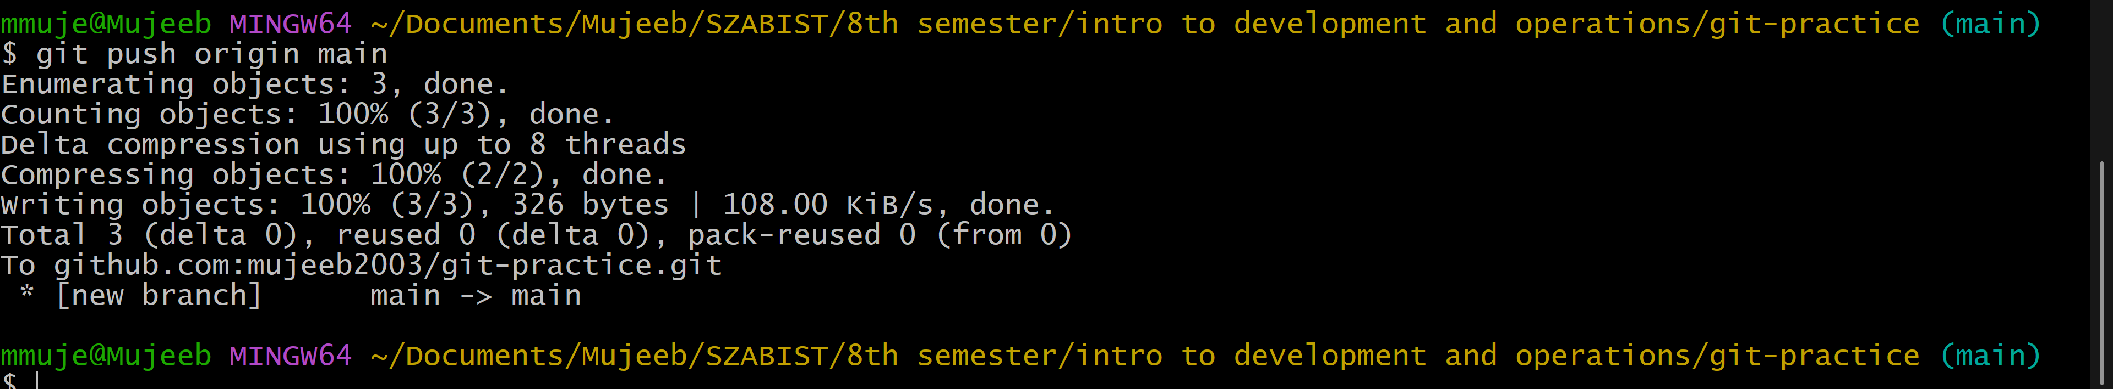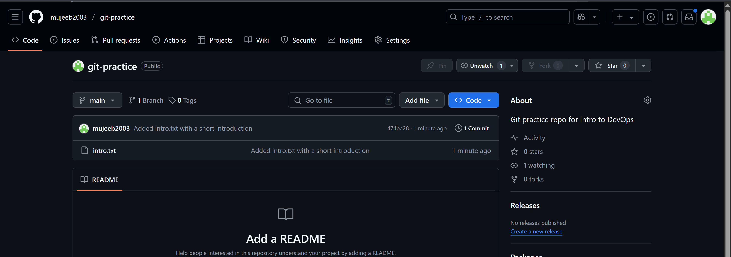

Step 8: Create a Branch and Additional Changes
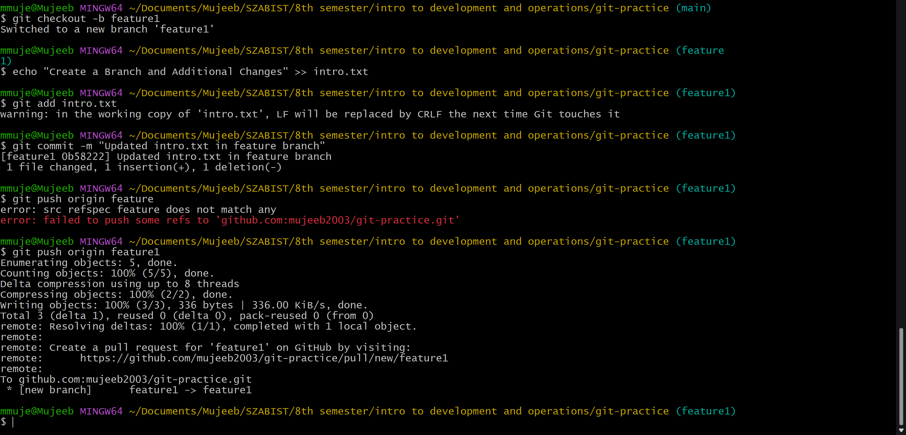

Step 9: Create and Merge a Pull Request
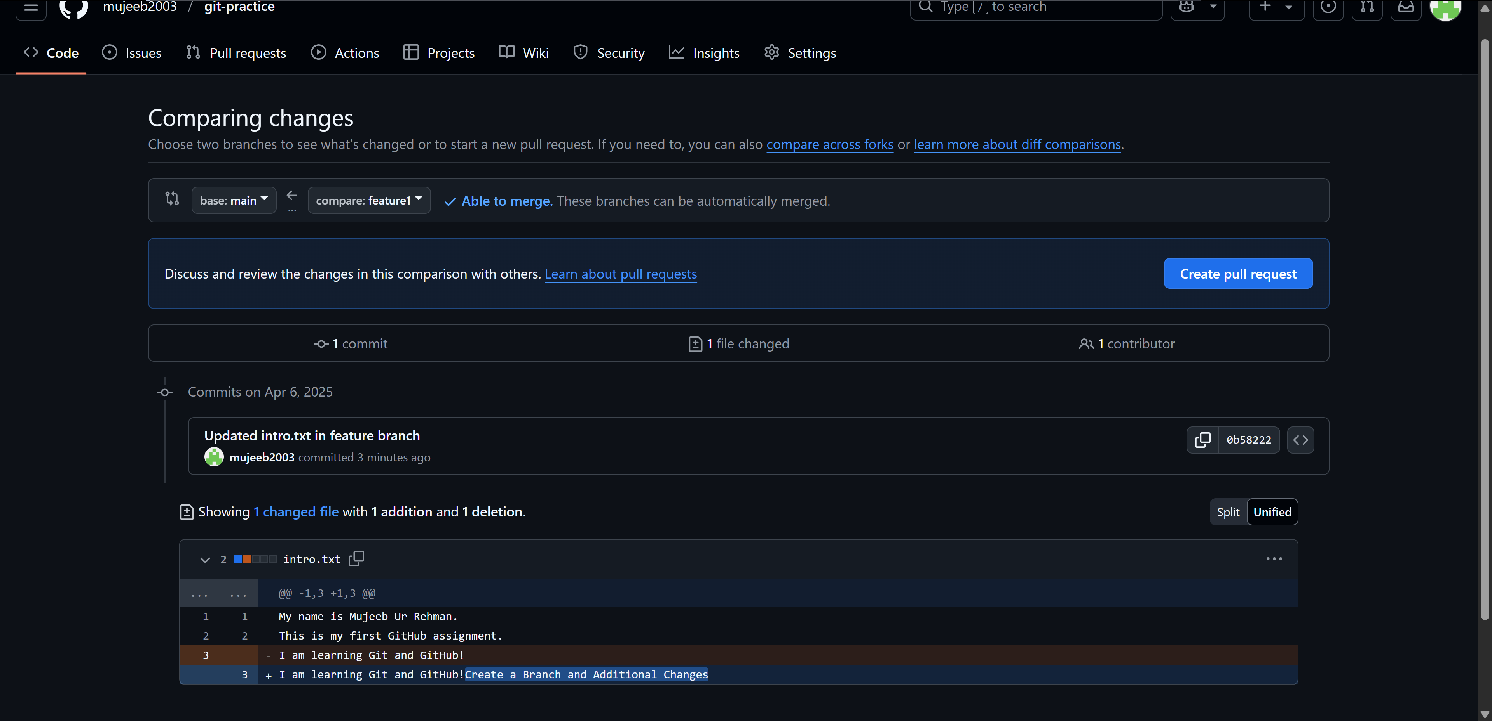
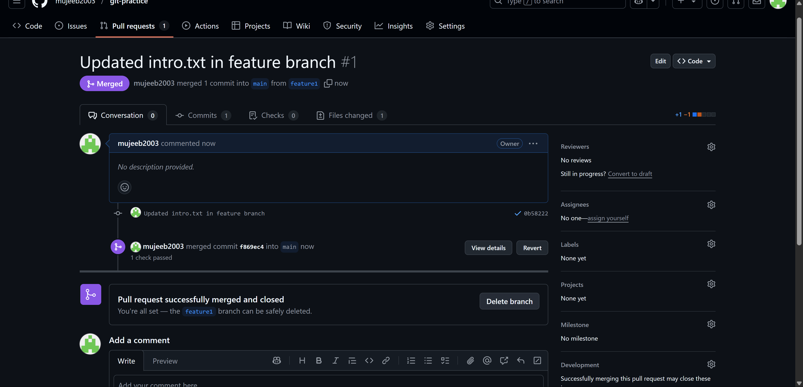

Step 10: Sync Local Repository
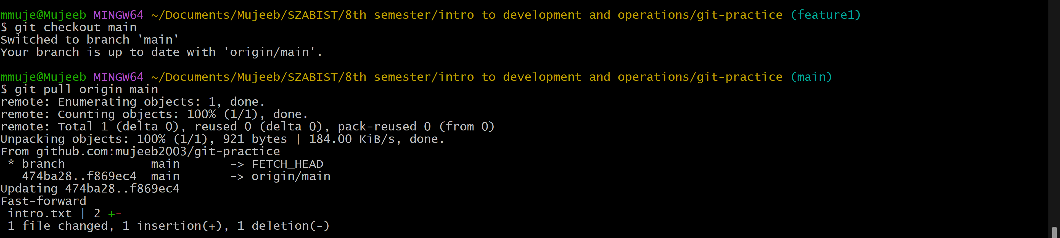

Github Repo: https://github.com/mujeeb2003/git-practice.git

